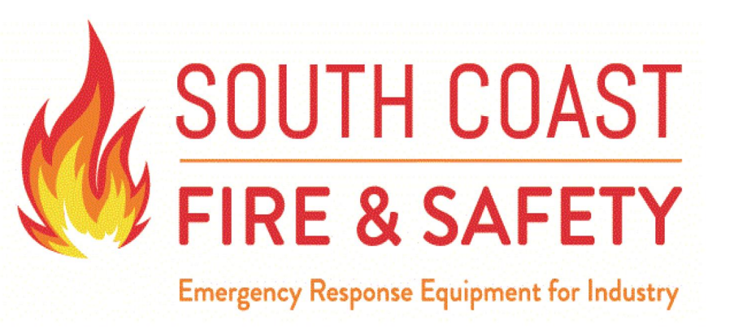

Please call 713-649-6691 for a Return Authorization number.

Thanks,
South Coast Fire & Safety Team

